<https://docs.microsoft.com/en-us/azure/event-hubs/event-hubs-quickstart-portal>

1. Create Event Hub Namespace

Azure Portal 🡪 Create a Resource 🡪 Internet of Things 🡪 Event Hubs

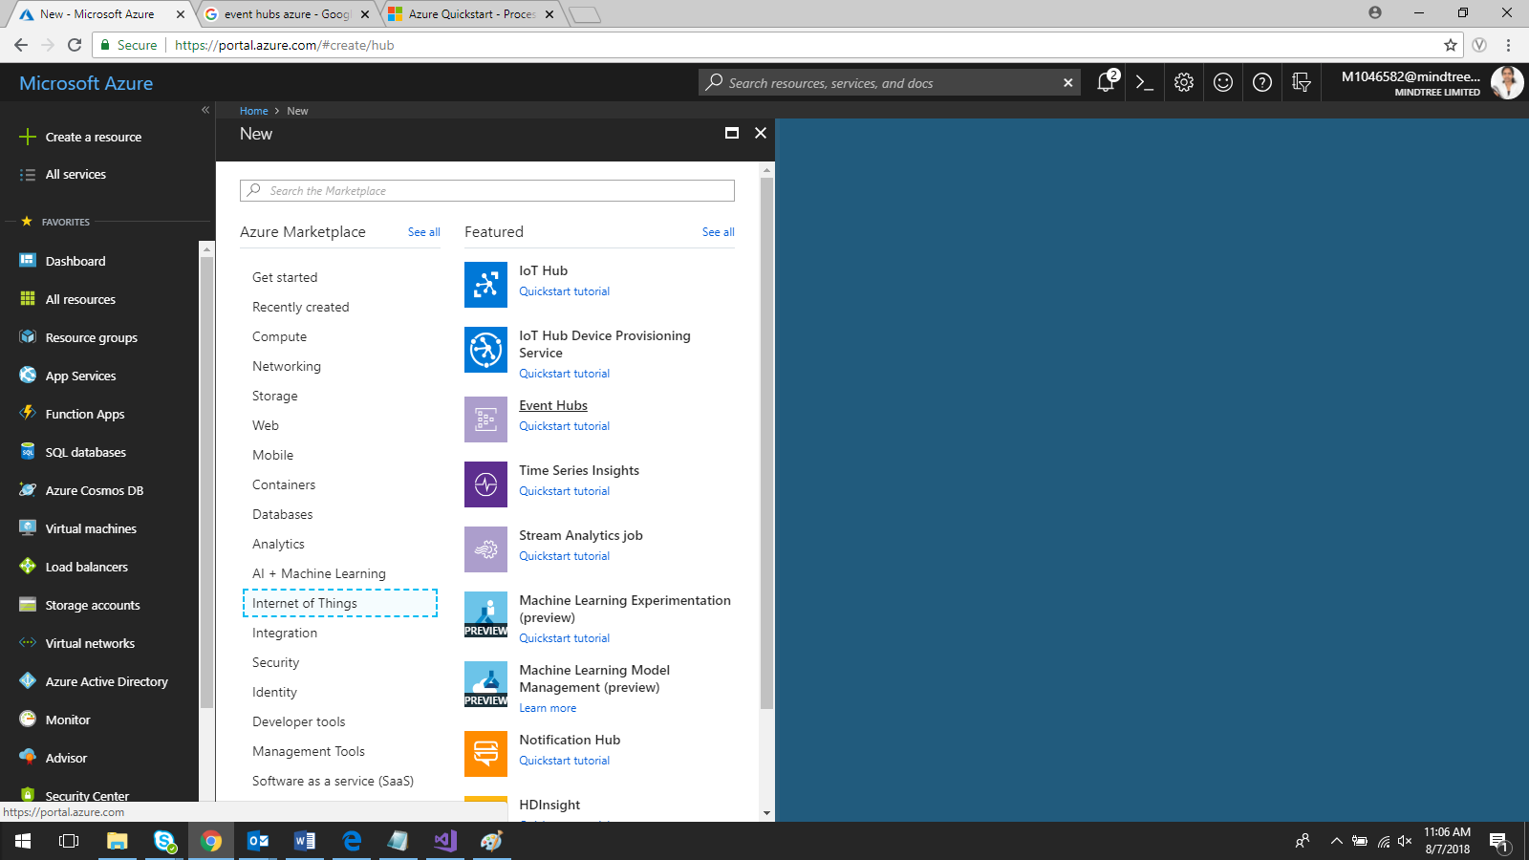

Fill the details

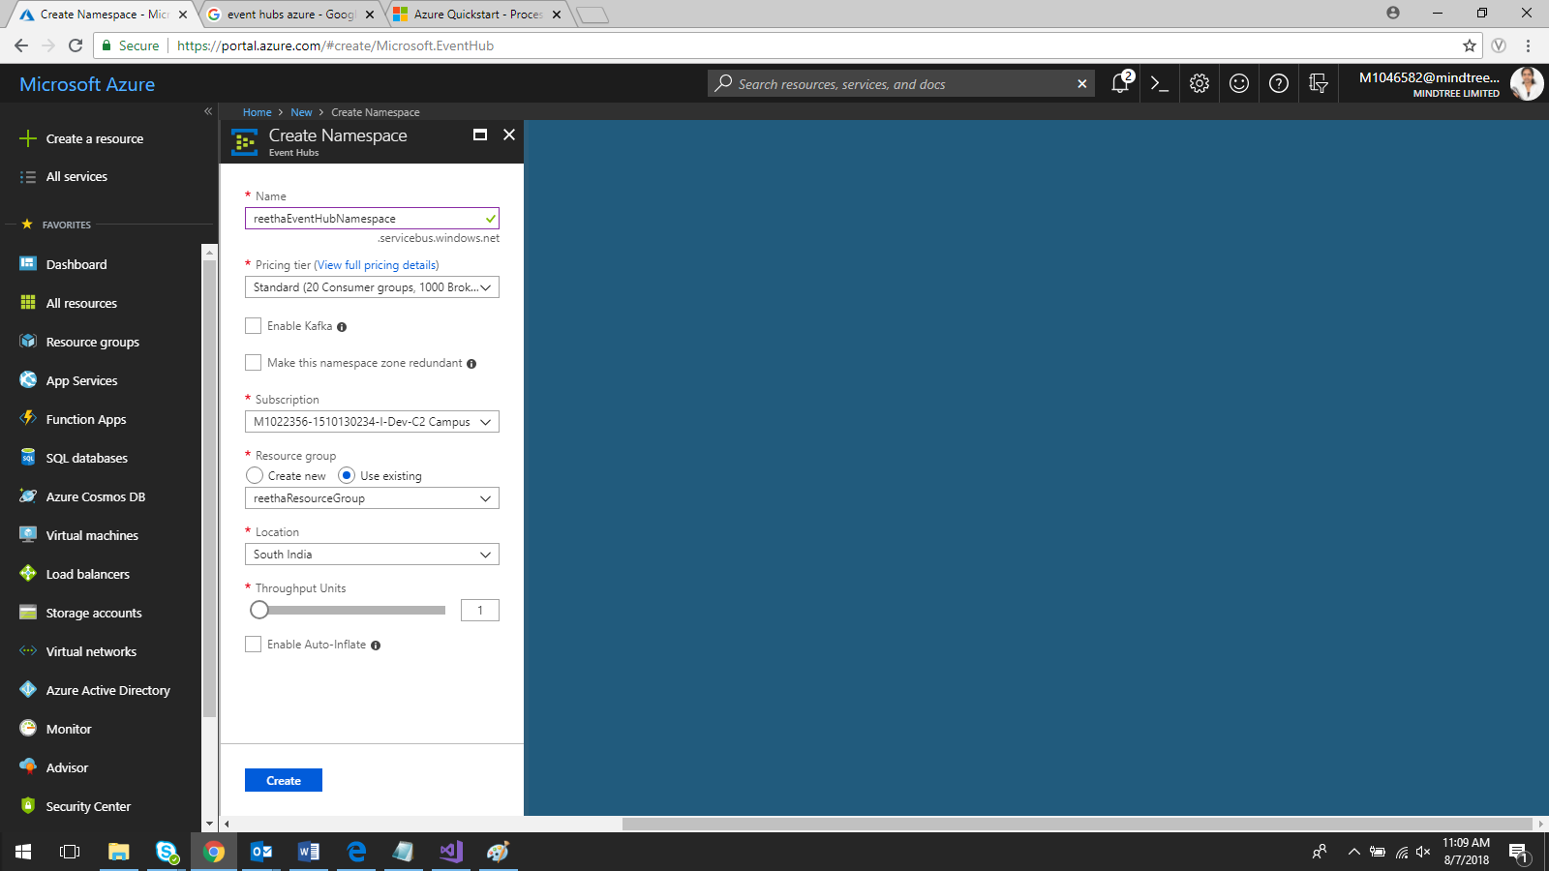

Click Create

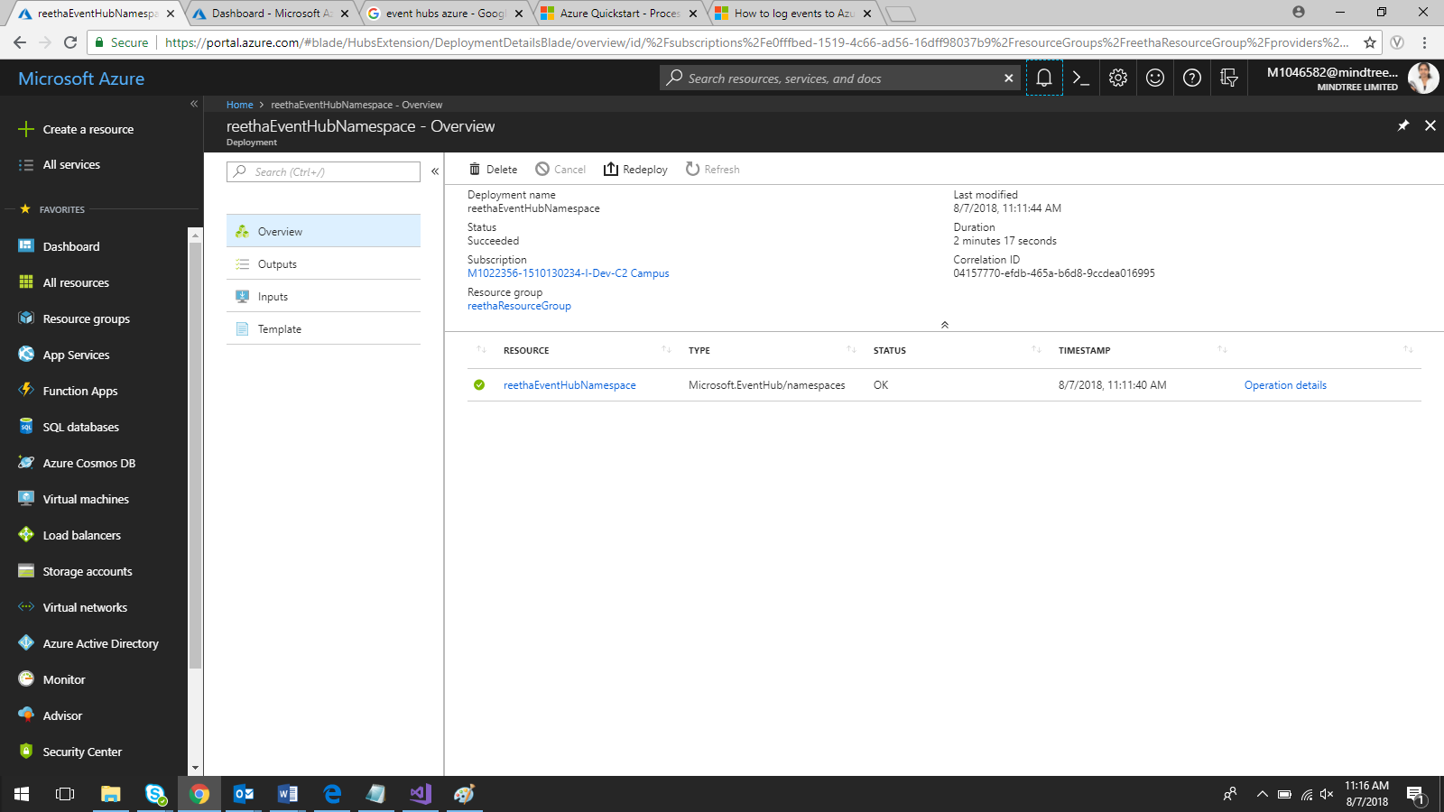

Click on the Namespace you created

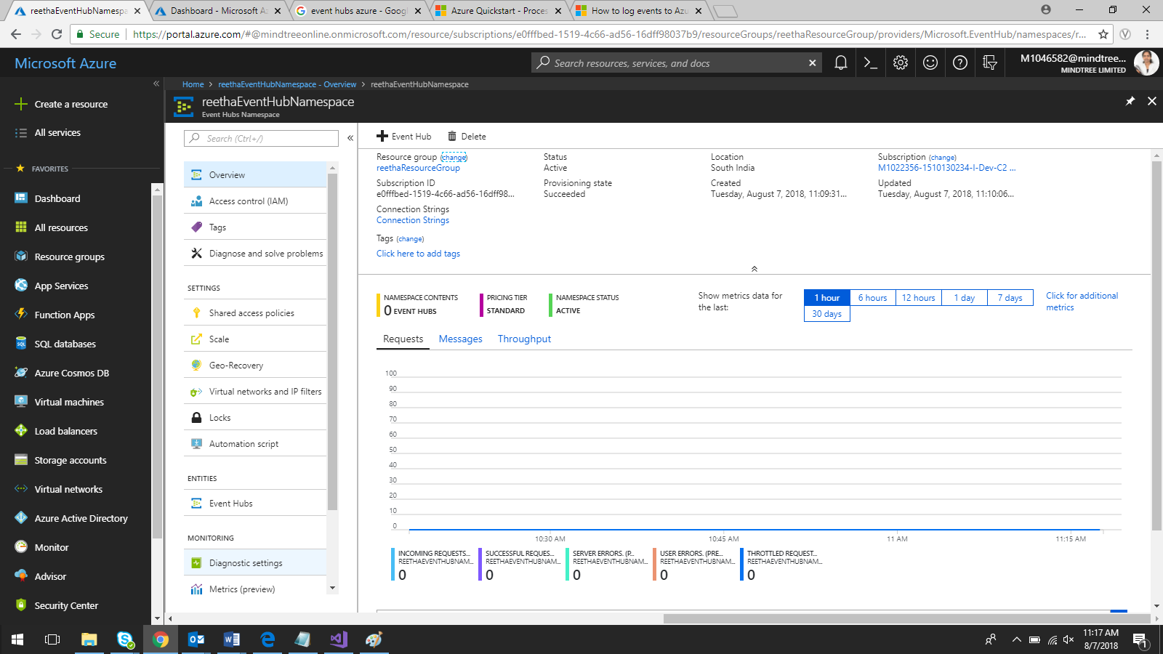

Click **Shared access policies**, and then click **RootManageSharedAccessKey**.

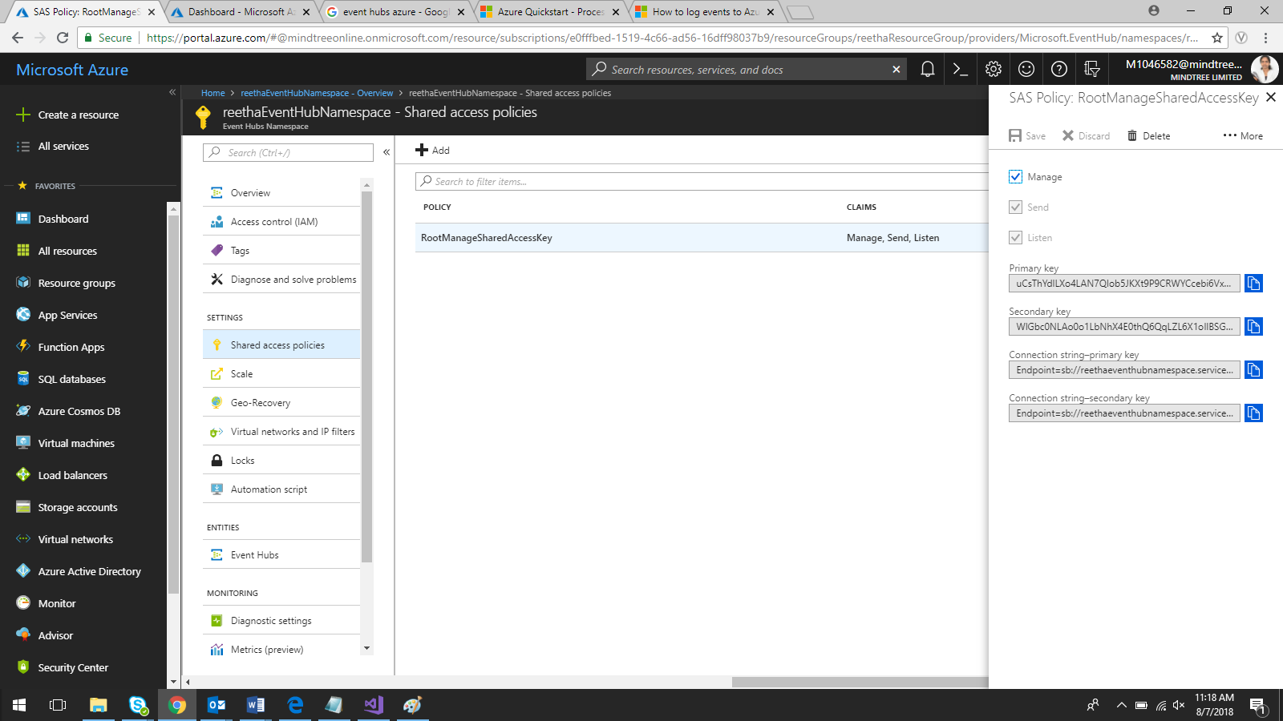

copy the **RootManageSharedAccessKey** connection string to the clipboard

Connection String – Primary: Endpoint=sb://reethaeventhubnamespace.servicebus.windows.net/;SharedAccessKeyName=RootManageSharedAccessKey;SharedAccessKey=uCsThYdlLXo4LAN7QIob5JKXt9P9CRWYCcebi6VxEQw=

1. Create Event Hub

In the namespace window, click **Event Hubs**.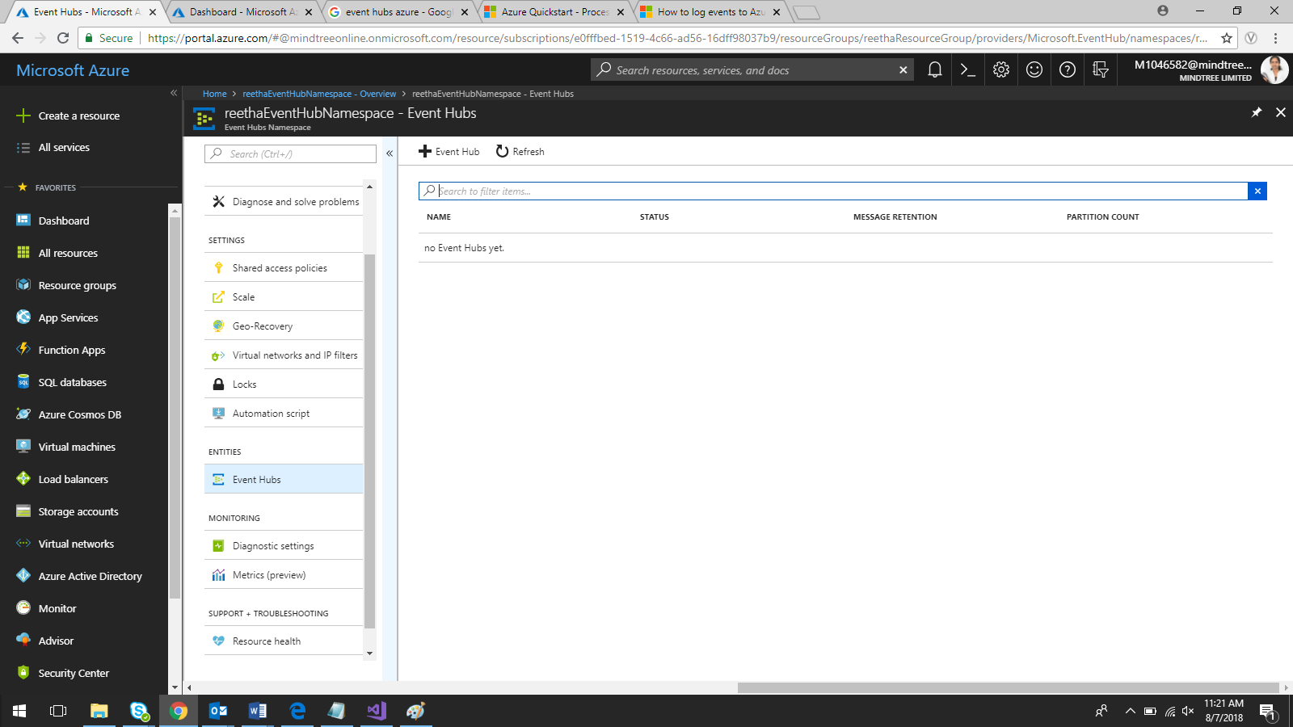

click **+ Add Event Hub**.

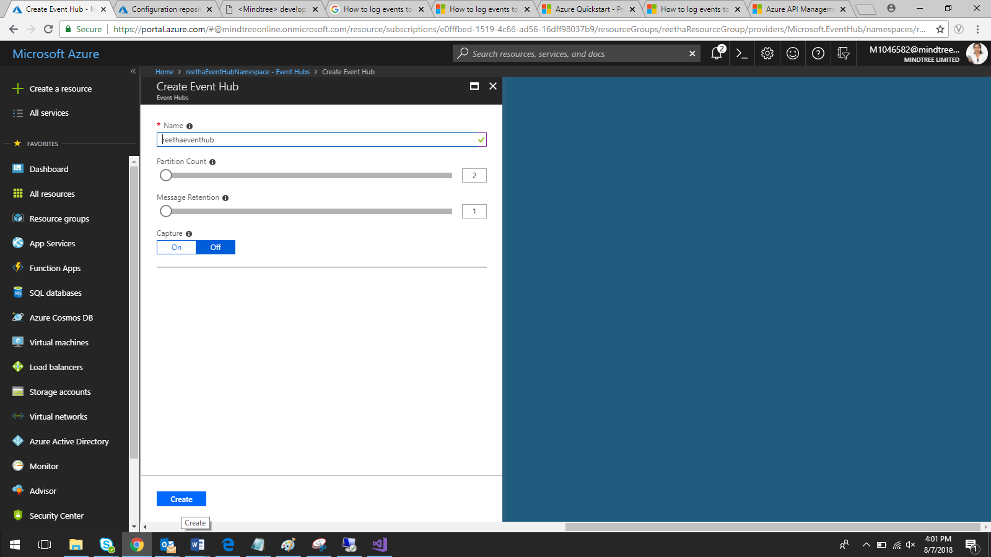

Click create

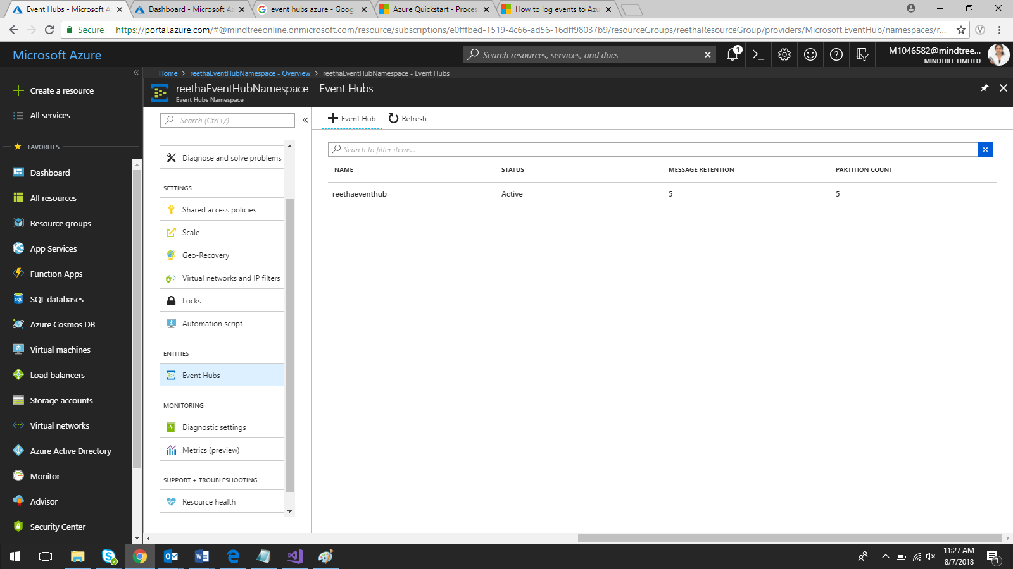

1. Open API Management

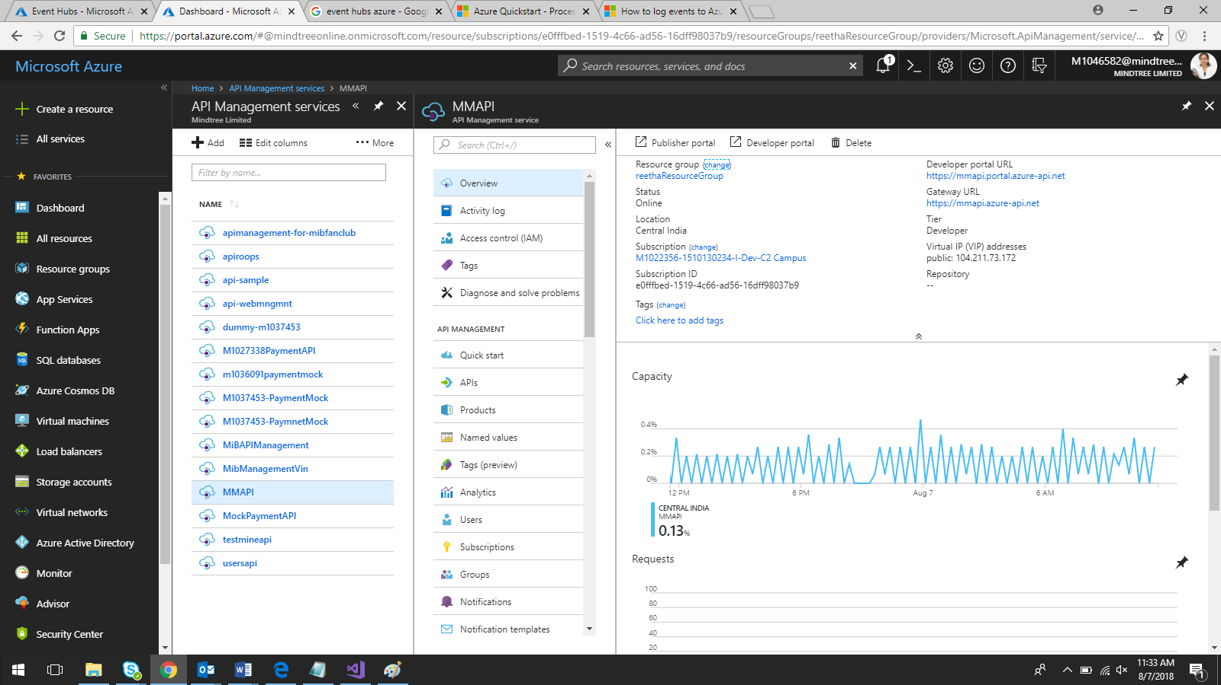

Click on Management API

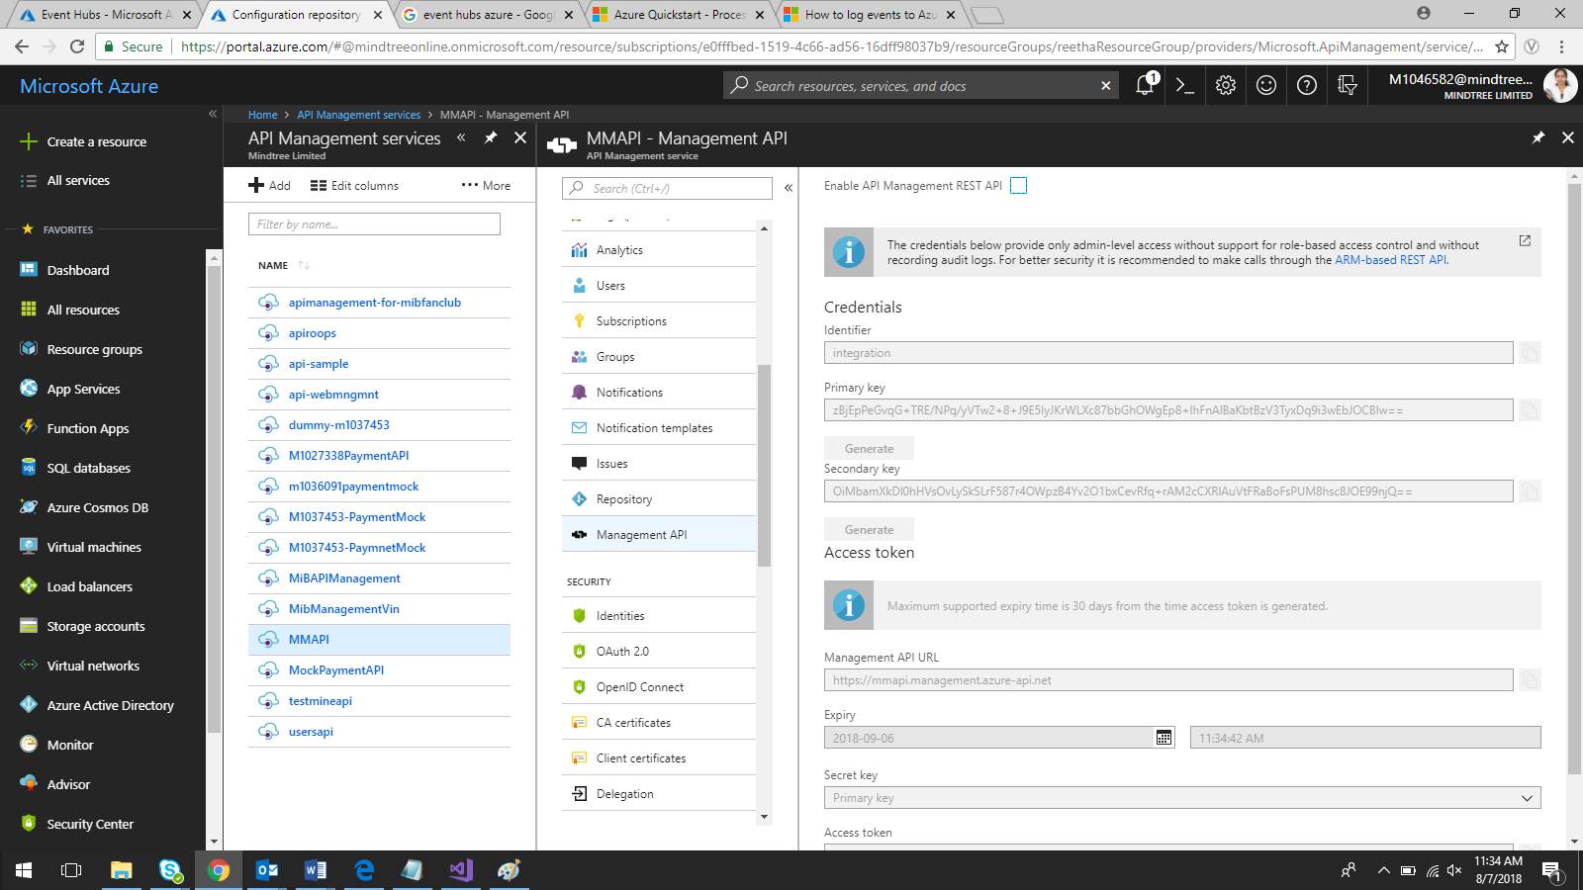

Check the checkbox near **Enable API Management REST API**

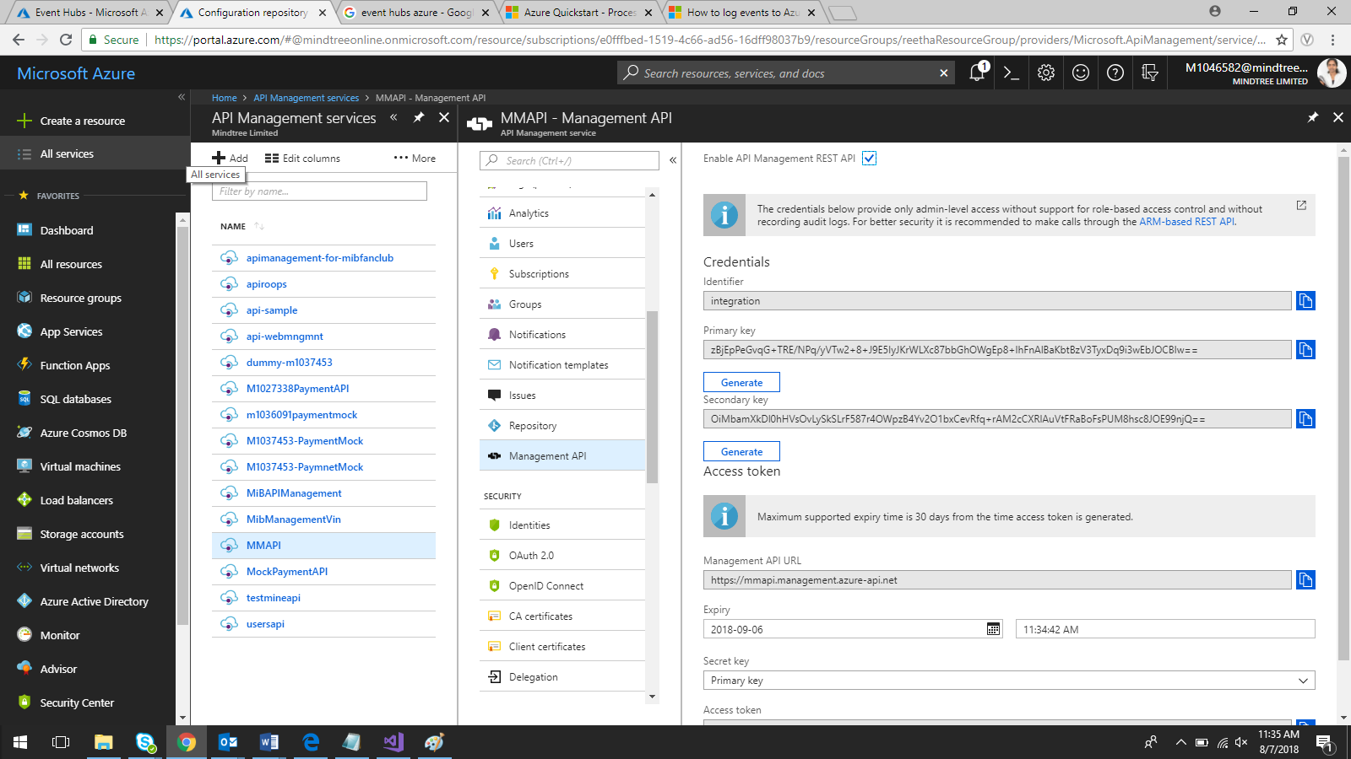

Generate Shared Access Key by click on Generate

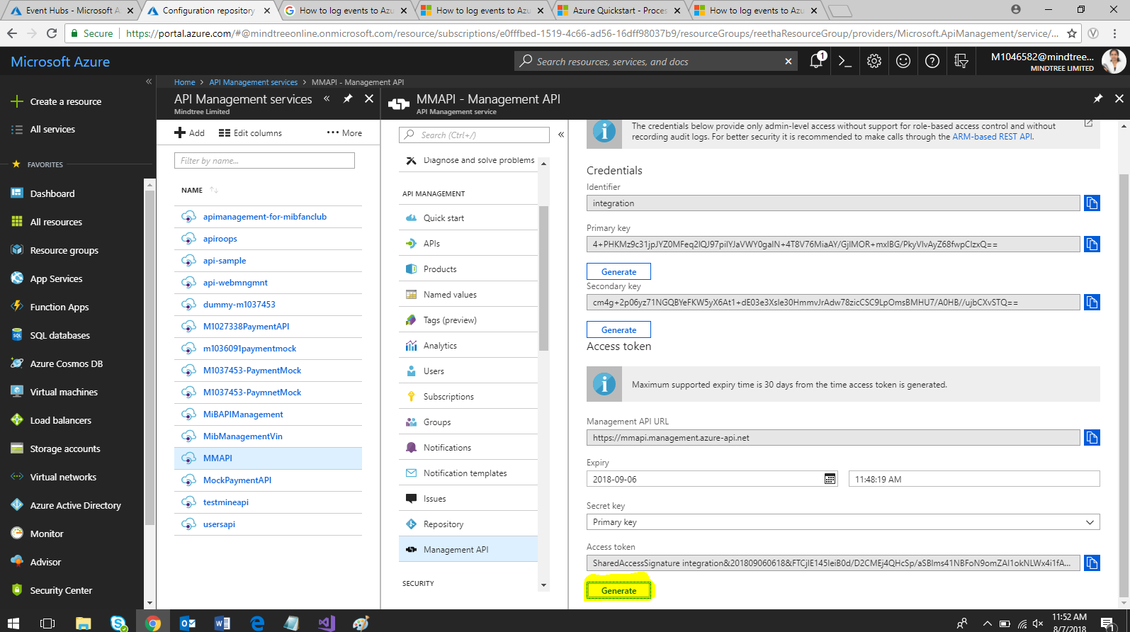

Copy the Access Token generated

**SharedAccessSignature integration&201809060618&FTCjlE145leiB0d/D2CMEj4QHcSp/aSBlms41NBFoN9omZAI1okNLWx4i1fA0wC5W2sO3C40whg6dCqHxPlcGQ==**

1. Create an API Management logger using ost Man

Connect VM and open post man website

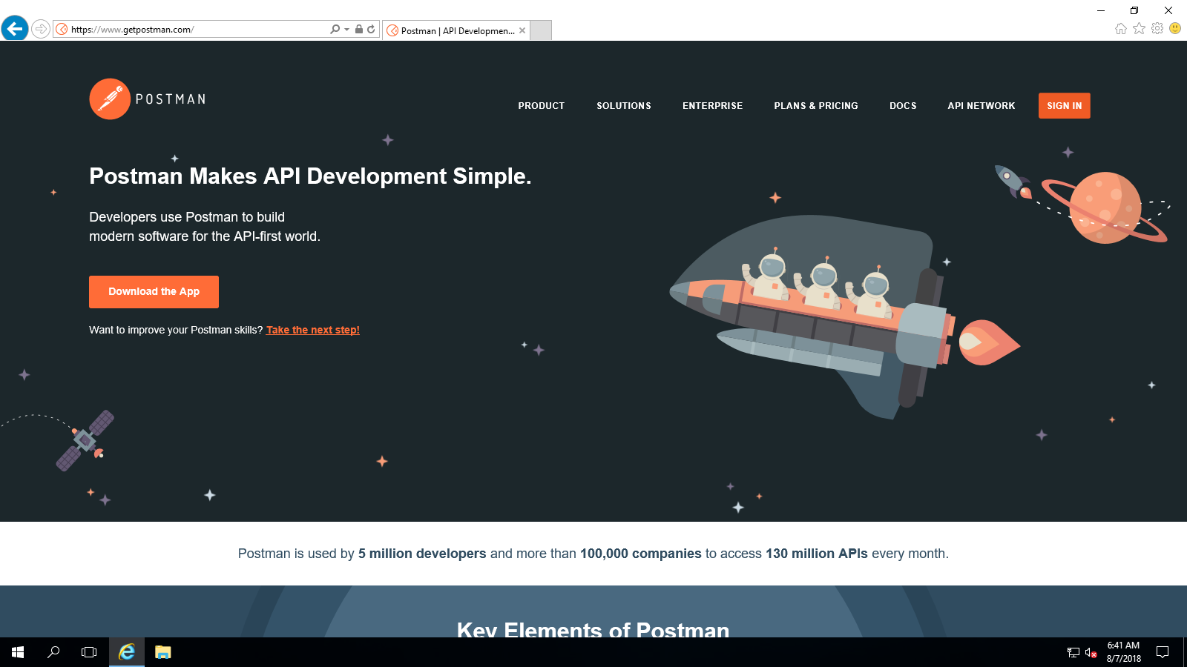

Download App

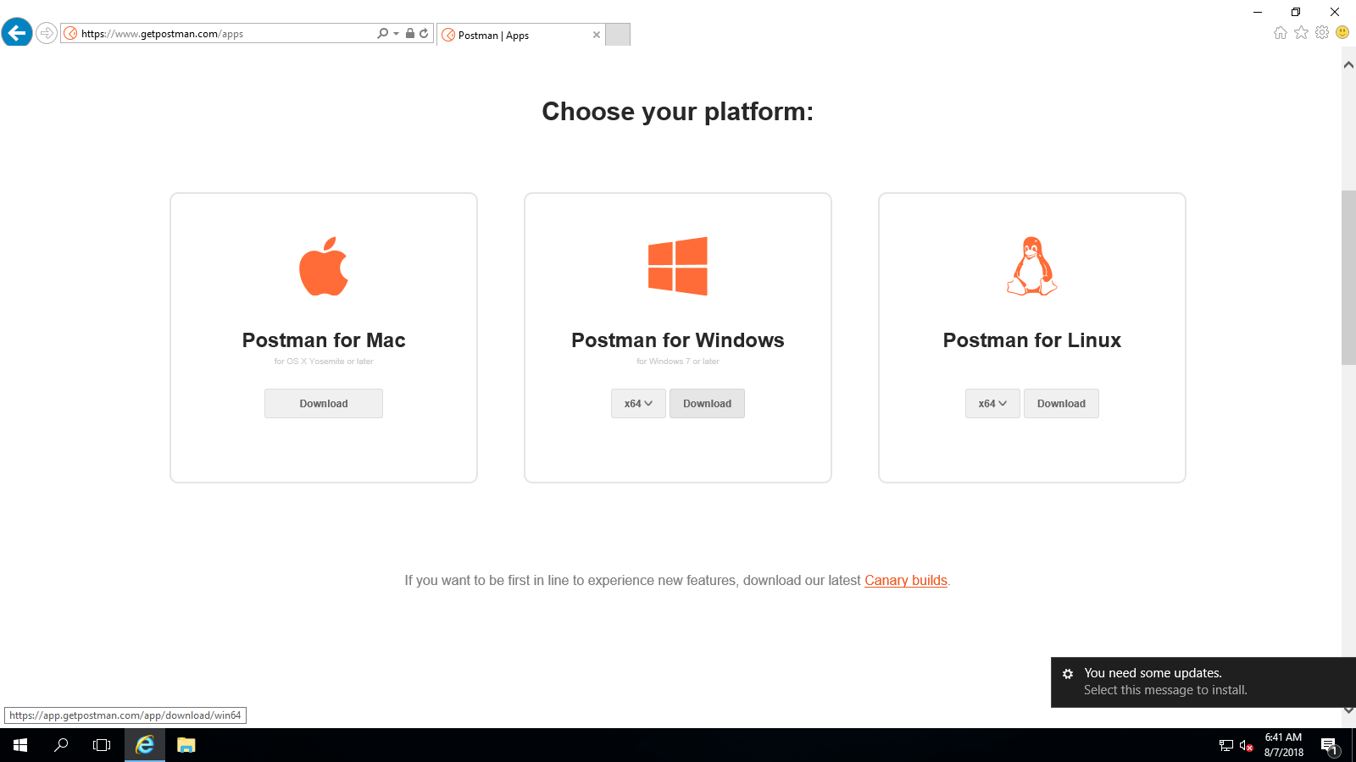

Install and open Postman App

Username: m1046582

Password: same as VM

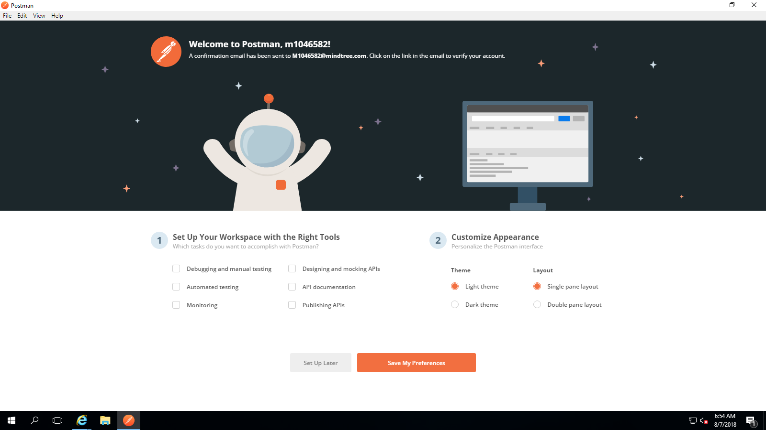

Click Save my preference

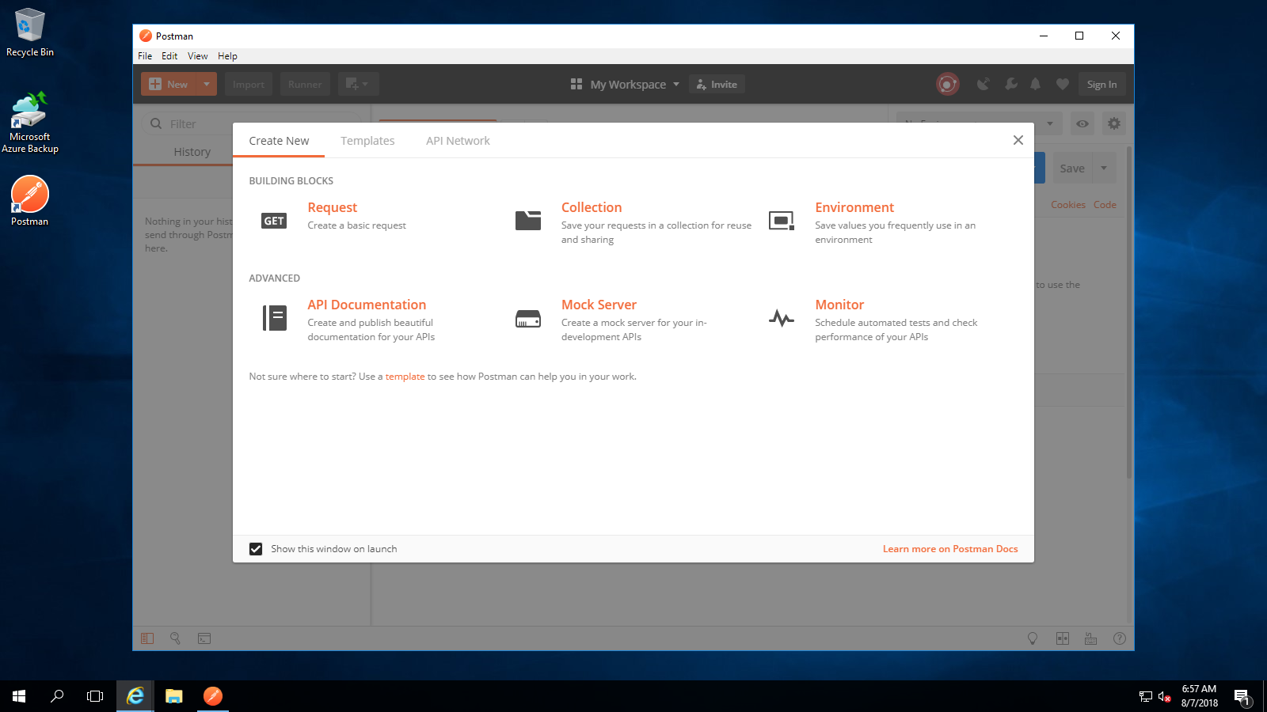

Close this window

To create a logger, make an HTTP PUT request using the following URL template:

https://{your service}.management.azure-api.net/loggers/{new logger name}?api-version=2017-03-01

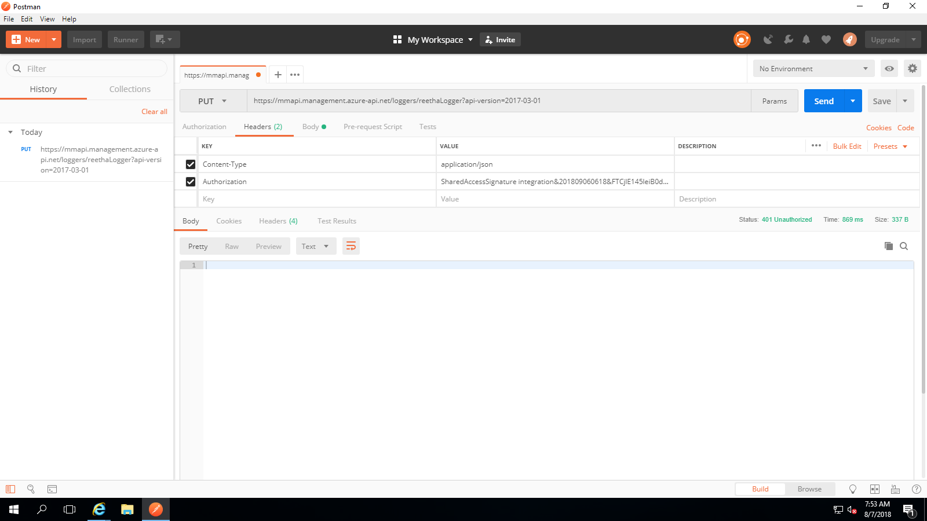

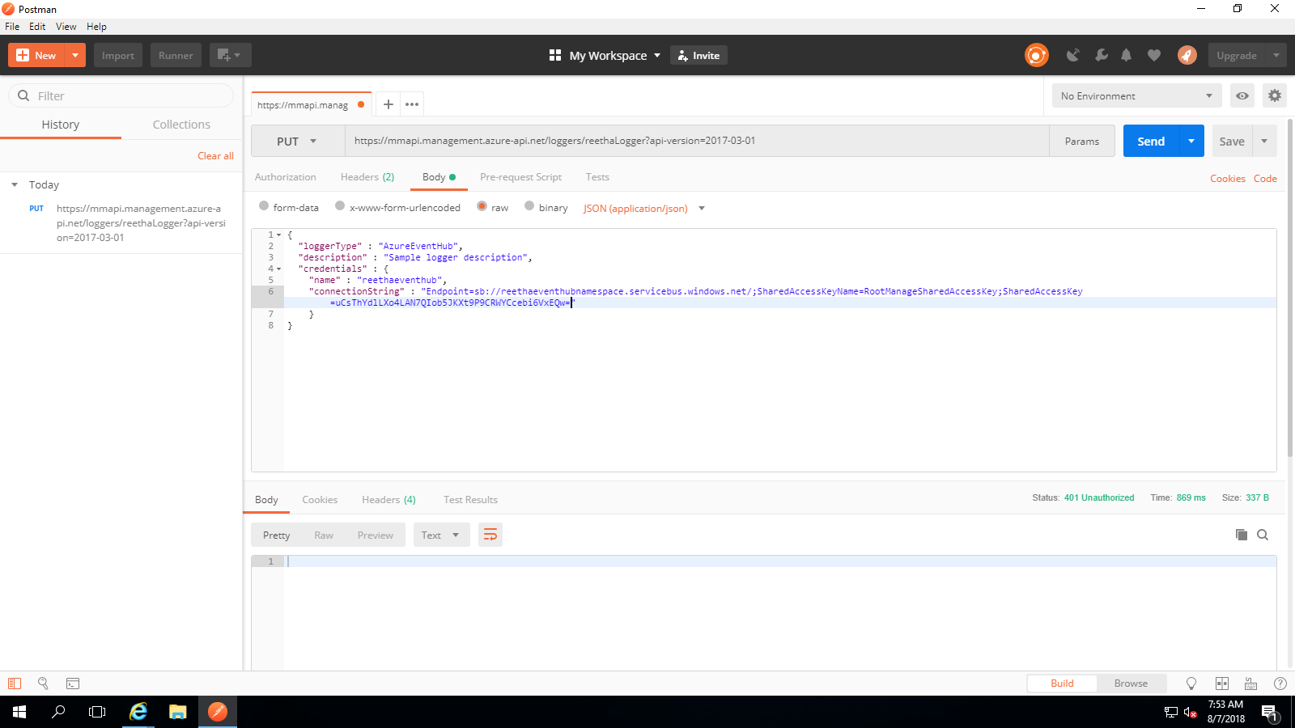

When you make the request, if the logger is created, a status code of 201 Created is returned.

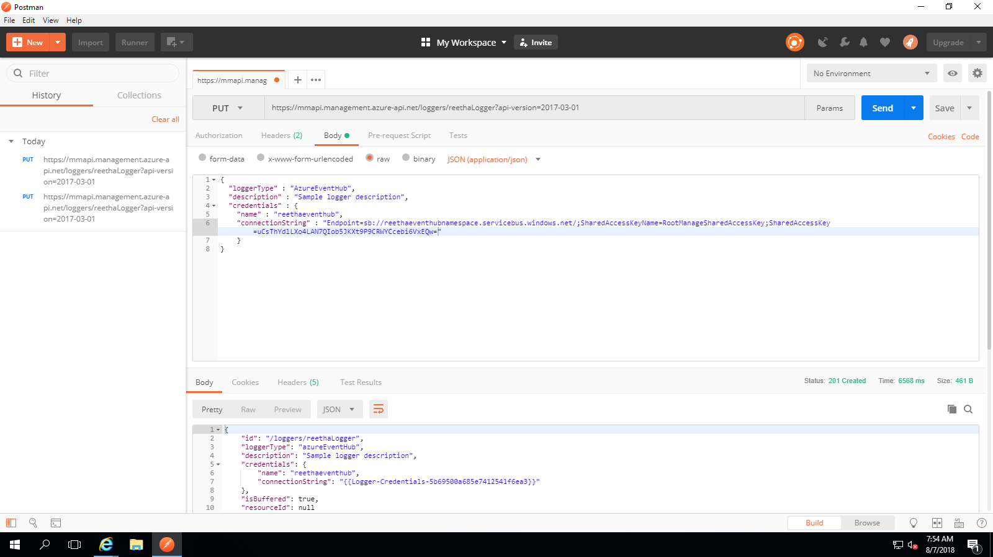

1. Create Stream Analytics Job

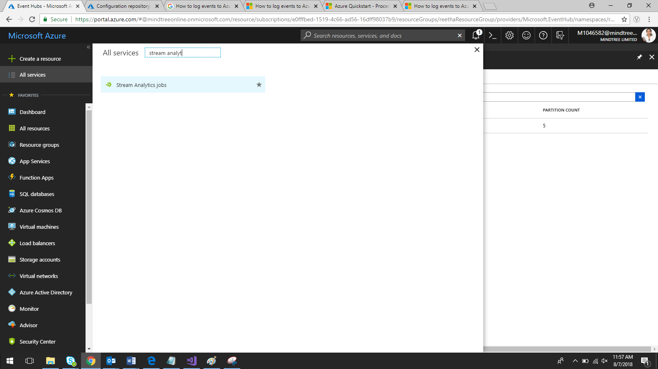

Click on Add

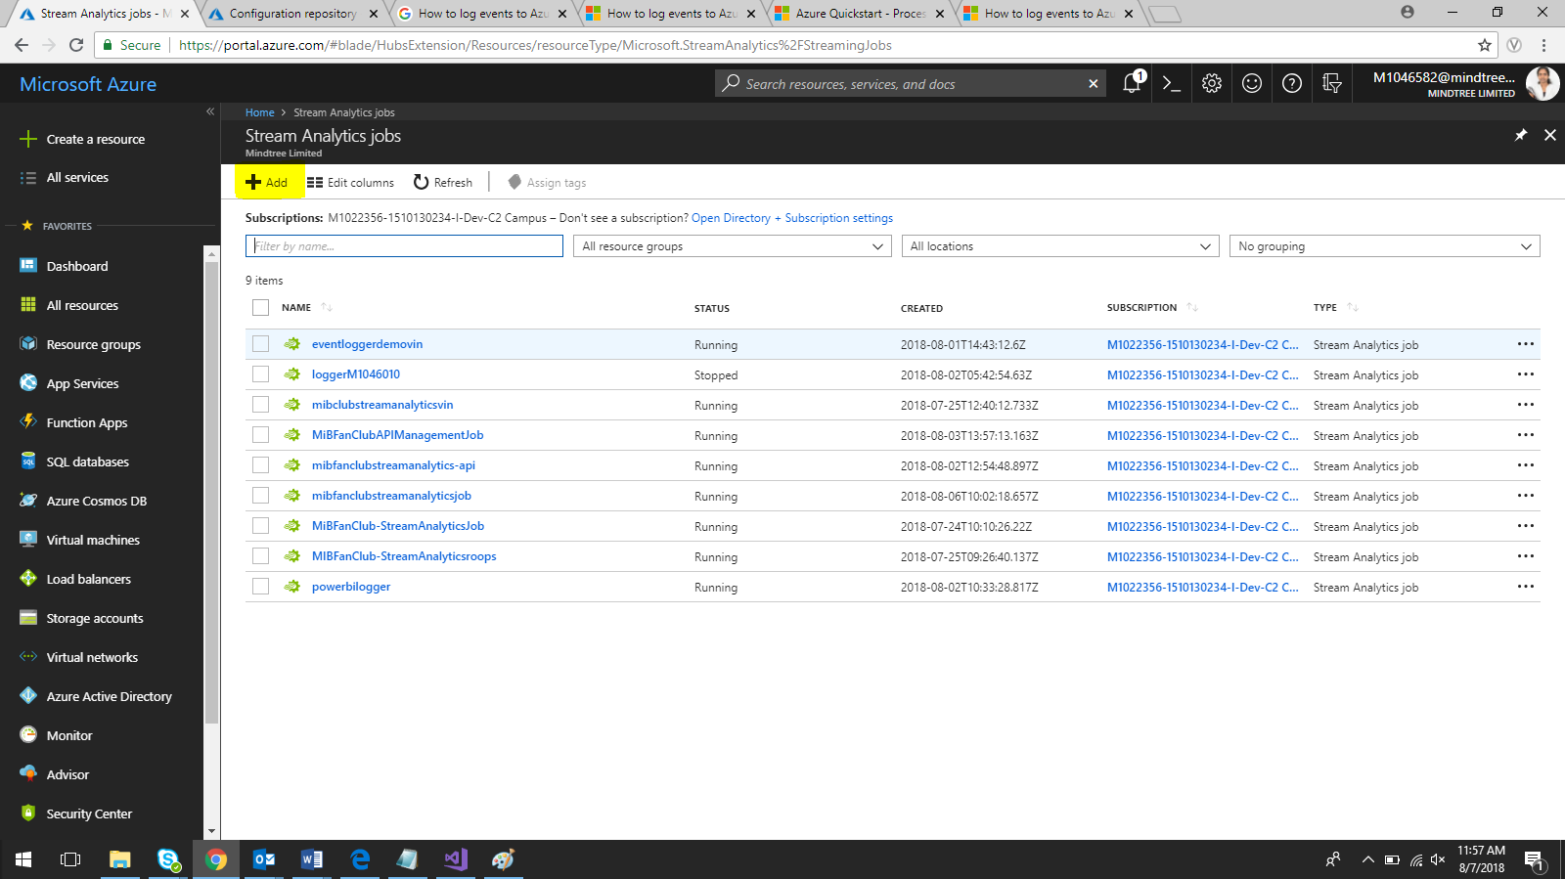

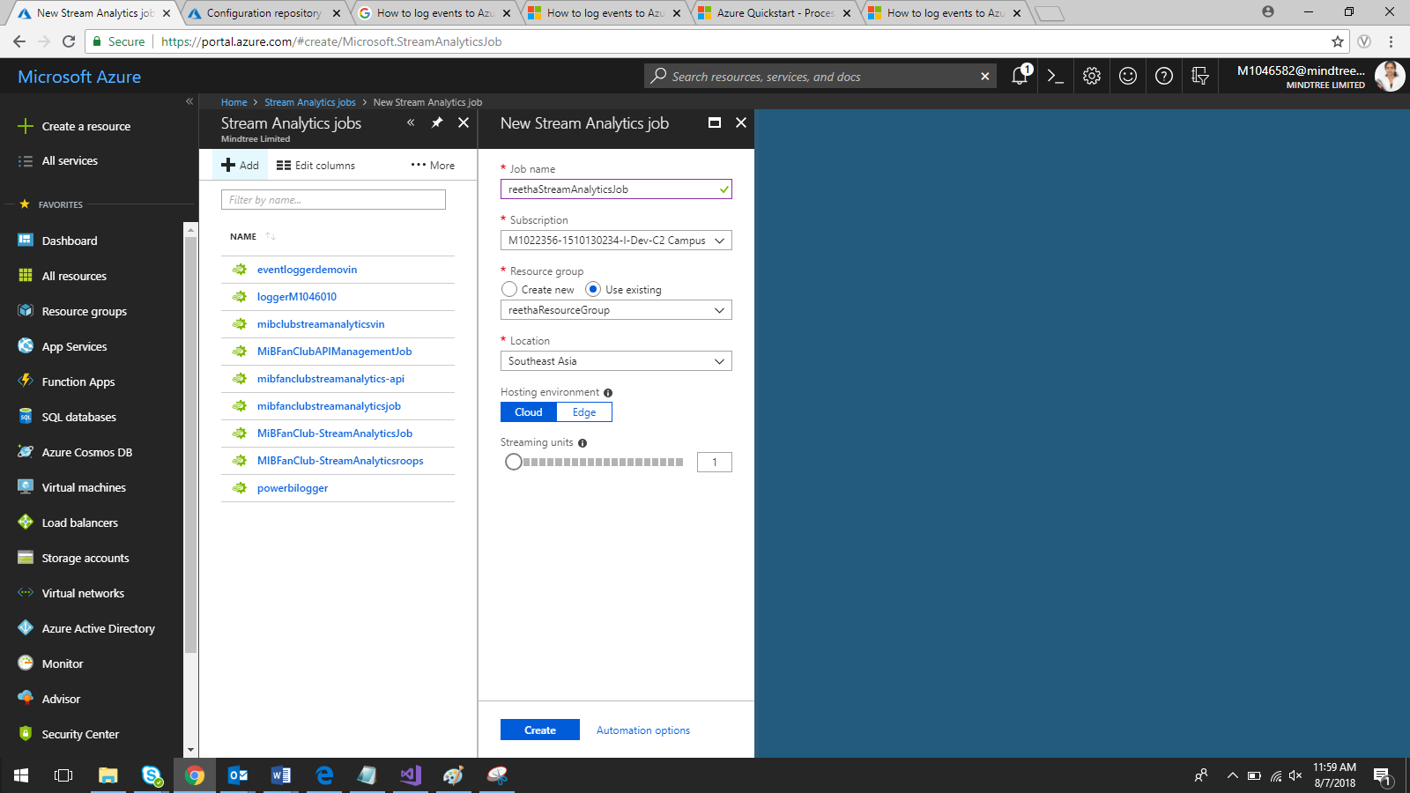

Click on Create

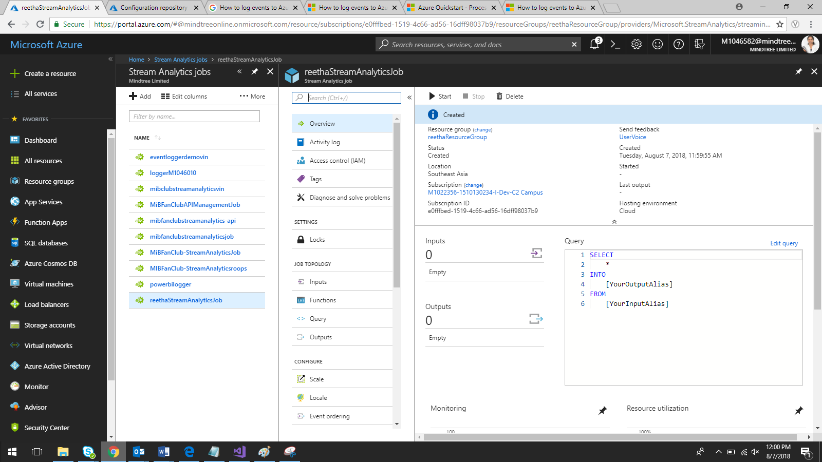

Set Input and Output:-

Click on Inputs

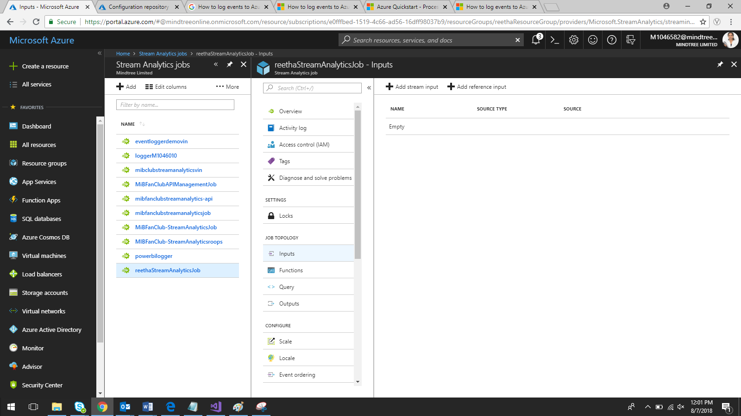

Click on Add Stream Input

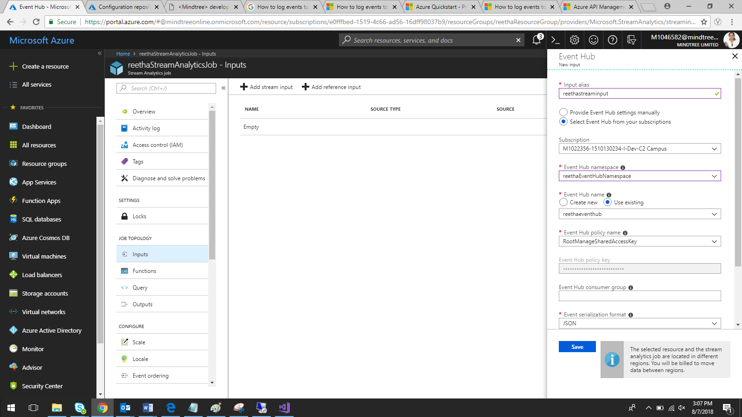

Click on Outputs

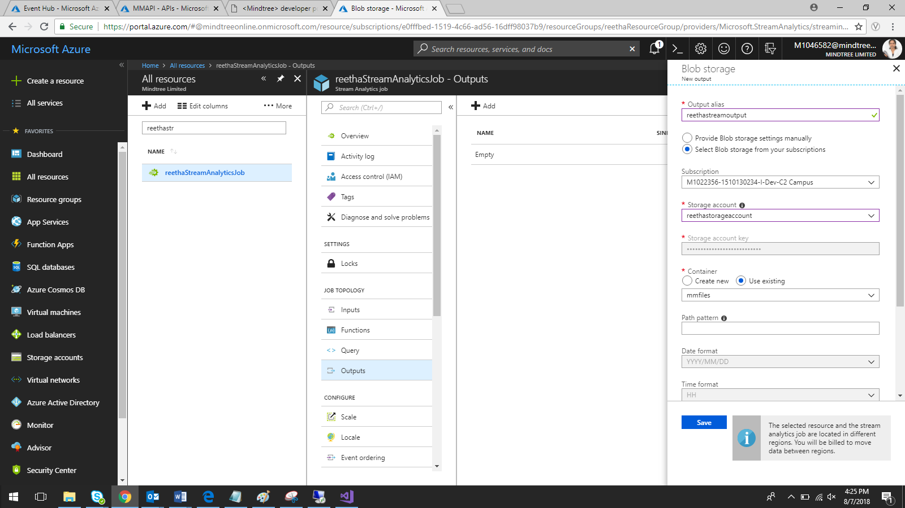

Click on Query

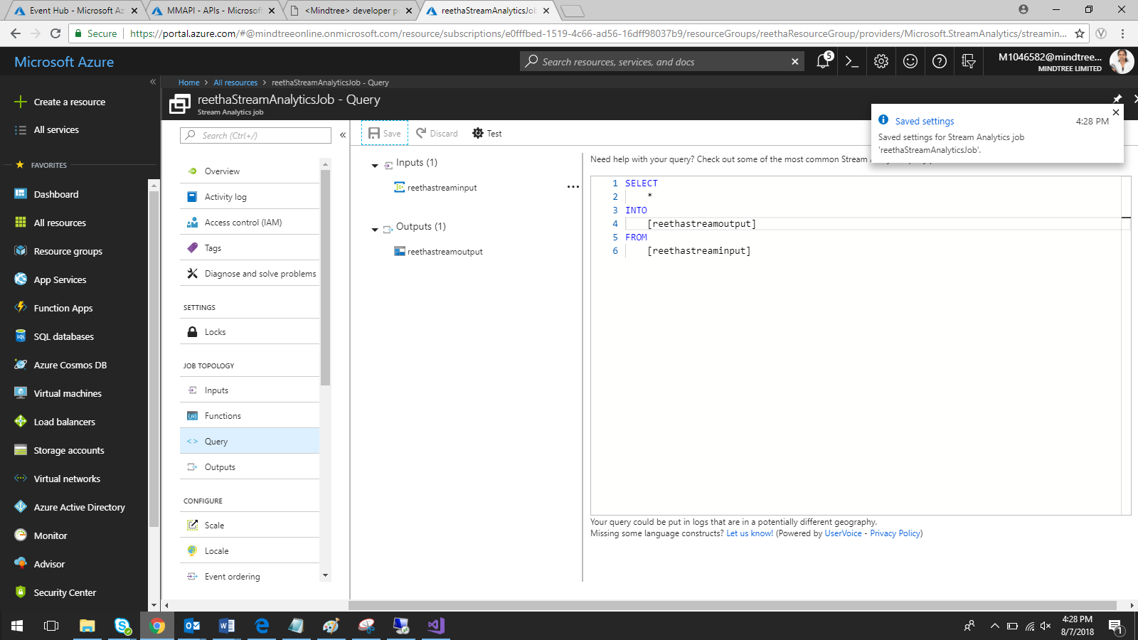

Click Save

Start Stream analytics job

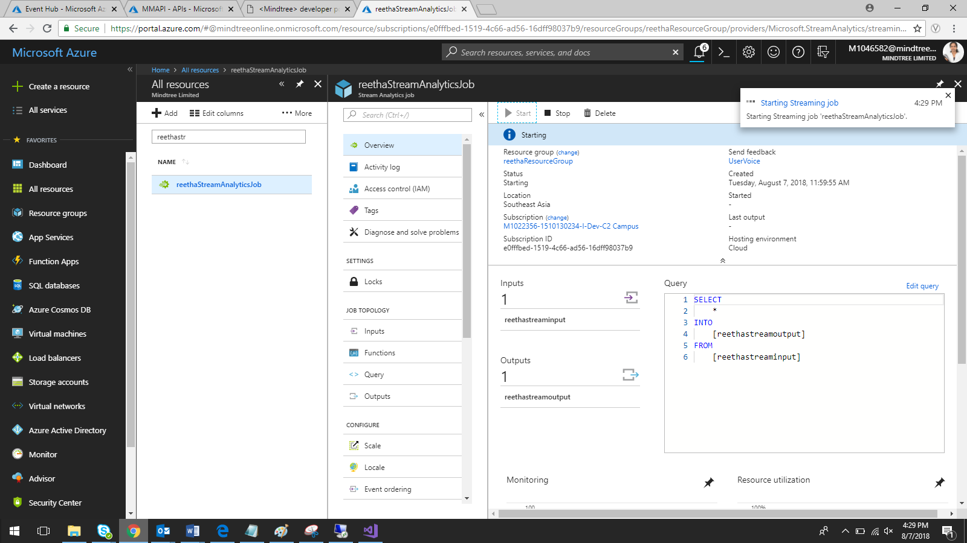

Open API and add the below inbound rule to all operations

<log-to-eventhub logger-id="reethaLogger">@( string.Join(",", DateTime.UtcNow, context.Deployment.ServiceName, context.RequestId, context.Request.IpAddress, context.Operation.Name))</log-to-eventhub>

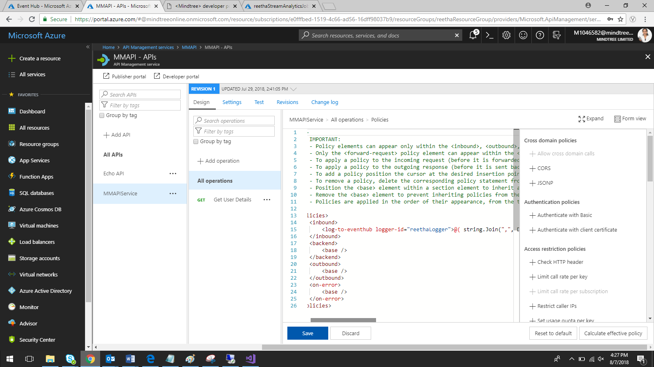

Run the API service and check the event hub and storage account